Lecture No. 17 PARASITOLOGY DR.Raad H.H.
Family Hymenolepididae
- Scolex with rostellum bear 1 raw of hooks ; suckers unarmed usually.
- Mature segment had 1 set of reproductive organs with 1 genital pore rarely 2.
- Larval stage Cercocystic cysticercoids
Genus Hymenolepis
Character | H.nana | H.diminuta
Final host | Man ; rodents | Rodents ; rarely Man
Length | 1-4 cm. | 2-20cm.
Rostellum | Armed with hooks | Unarmed
Life cycle | Direct ; autoinfectin sometimes | indirect
2nd. host | Beetle Tenebrio in rodents usually and Man sometimes. | beetles Tribulium
Egg | Polar nodes With filaments  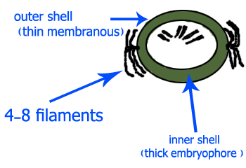 | Polar nodes Without filaments  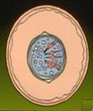
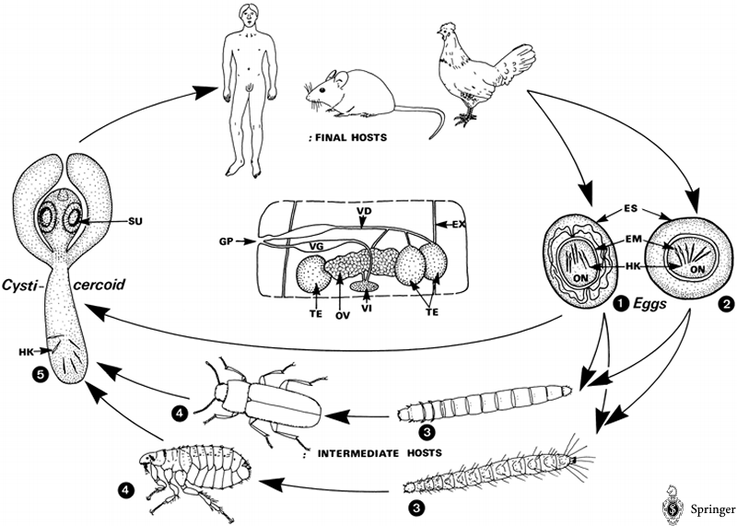

Fig. Life cycle of of the family Hymenolepididae. A Species and final hosts (others see ): of mice and humans, 4–6 cm long and 1 mm broad, with 24–27 rostellar hooks; of rats, mice, dog, and humans, up to 6 cm long and 3.5 mm broad, no rostellar hooks; Echinolepis (Hymenolepis) carioca of chickens and birds. up to 8 cm long and 3 – 5 mm broad, scolex has no rostellar hooks. The sexually mature are characterized by three spherical testes (TE); there is no distinct border wall between the proglottids (dotted lines). B Intermediate hosts (see ). 1–4 Eggs containing the larva (1 H. nana, 40–60 × 30– 50 gm; 2 H. diminuta, 60–80 × 70 μm) are infectious to various insects (larvae, adults) as intermediate hosts (3, 4). 5 Inside the body cavity of these hosts a second larva is formed, which grows to be a mature tapeworm when the is swallowed by the final host. In H. nana the intermediate host is optional; when eaten by a man or a rodent, the egg (1) hatches in the duodenum, releasing the which penetrates the mucosa. Here it develops directly into a cysticercoid (5). In about 6 days the emerges into the lumen of the small intestine, where it attaches and grows to be a mature worm. EM, (layer surrounding the oncosphaera); EX, excretion system (longitudinal); ES, GP, genital pores; HK, hooks of oncosphaera; ON, oncosphaera; OV, ovary (); SU, sucker; TE, VD, vas deferens, VG, vagina with enlarged seminal vesicle; VI,

Family Mesocestoididae
- 4 suckers
- Without rostellum or hooks
Genus mesocestoides
- A genus of tapeworm, containing several species, found as adults in birds and mammals (final hosts).
- Life cycle needs two intermediate hosts.
- The larvae or cysticercoid stage develop in invertebrates.
- Human infection has been reported and is probably acquired from eating inadequately cooked meat of animals infected with the second larval stage known as the tetrahythridium.
- Mesocestoides corti, Mesocestoides lineatus, Mesocestoides variabilis :
found in the small intestines in a range of carnivores including dogs, foxes, cats and humans. They may cause enteritis in humans, but are innocuous in other species. The worm has an unusual life cycle and has a stage of tissue invasion which may cause peritonitis.

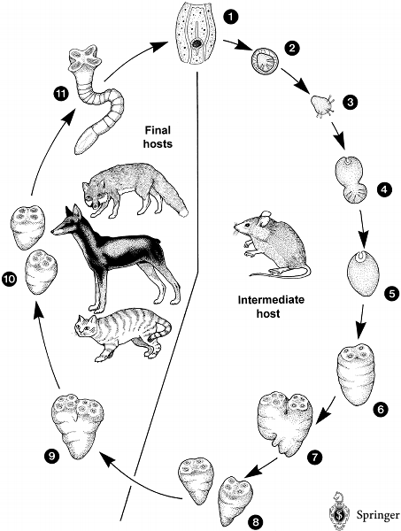

Fig. Life cycle of Mesocestoides sp. in its hosts. 1 Terminal with the characteristic, thick-walled (PO) which is filled with eggs. 2 Egg with larvae which are ingested by the first 3–6 Suggested development in the first intermediate host. To date it is not known whether oribatid may be first intermediate hosts. 7–9 Development in the second intermediate host which cannot be infected directly by eggs (2). Larvae, so-called tetrathyridia (7), occur in the body cavities of several animals (mainly mice, but also dogs, cats and snakes). The reaches a size of 1.5 × 1 mm and is provided with four suckers (SU). Reproduction of these tetrathyridia is common and proceeds as longitudinal division (DI, fissiparity). 10–12 Final hosts such as foxes, dogs, cats and other carnivores become infected by ingesting infected tissues of the second intermediate hosts (and perhaps by swallowing first intermediate hosts (6–10)). Inside the small intestine divisions (10) may be repeated. Finally, the tetrathyridia grow (12) to be adult worms with many (reaching about 40 cm in length) or they may leave the intestine and enter tissues or body cavities where another asexual may occur. DI, direction of division; EX, excretion canal; PO, paruterine organ (filled with eggs); PR, proglottids; SU, sucker; UT, uterus.

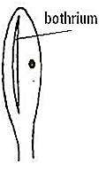
Order Pseudophyllidea (Tape worms )
Diphyllobothrium latum (Fish tape worm )
Known also as the human ‘broad’ tapeworm
Parasite causing a disease called ” Diohyllobothriosis”.
Morphology :
Length : about several meters (10 m.)
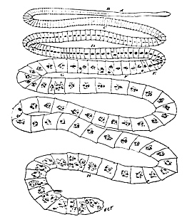
scolex is spatulate with no rostellum or hooklets
2 “ Botheria” situated with one dorsally and
one Ventrally longitudinal grooves.
Proglottids : up to # 4000 10 meters or more;
mature & gravid are wide than long ;
gravid segment have Coiled Rosette
Tube “ Uterus centrally located" .
segments & eggs may be found in Human feces ,
eggs could be found in the intestine .

Eggs : ovoid in shape possess an
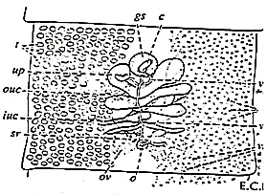
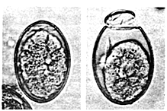
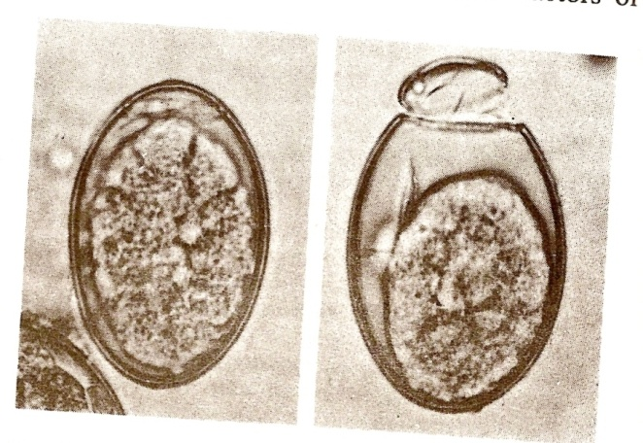
operculum within thin shell .
Uterus

life cycle:

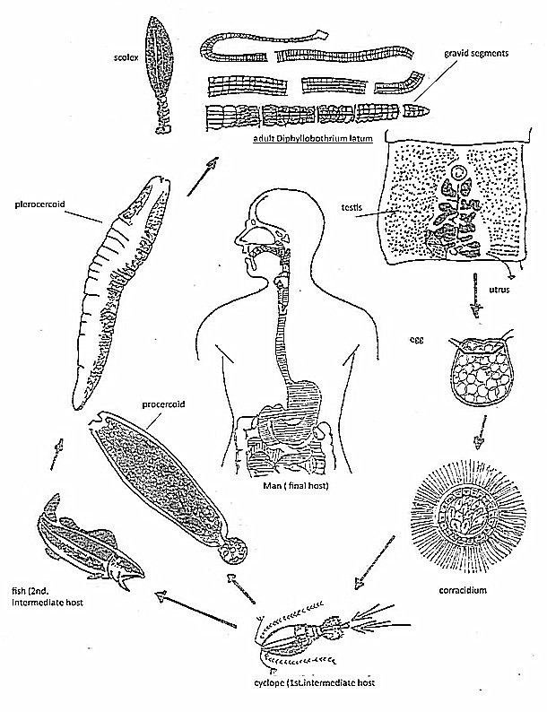
life cycle:

Pathogenesis :
- Pernicious anemia due to absorption of vit. B 12 by adult worm .
- Esinophilia .
- Slight leucocytosis .
- Jejunal inflammation due to attachment of theScolex .
Epidemiology:
- worldwide distribution especially north Europe , Japan Canada , USA
- SEVERAL FACTORS are need to complete worm’s life cycle e.g. fresh water , insect ( Cyclopes ; crustacean ) , fish ( Salmon , trout spp.)
- Customs in some areas e.g. Eating raw – salted fish meat lead to spread infection .
- Dogs ,cat, and pig & Bears are reservoir of Diphyllobothrium latum.

Spirometra
- Genus contains spp. E.g. Spirometra mansoni , Adults live
In feline small intestine (length 60-100cm), larva (30cm)
- S. mansonoides , S. erinacei .
Characters :
- It causes a disease called SPARGANOSIS.
- Members of genus Spirometra similar to Diphyllobothrium genus, both had 1st. intermediate an arthropods “ Cyclopes” .
- Differences between Spirometra & Diphyllobothrium are :
- ^{2nd}. intermediate host of Spirometra are Frogs ; snakes & mammals , unlike in Diphyllobothrium as Fish .
- The 2nd. Larval stage called “ SPARGANUM “ .
- Spirometra definitive host are Dogs & cats .
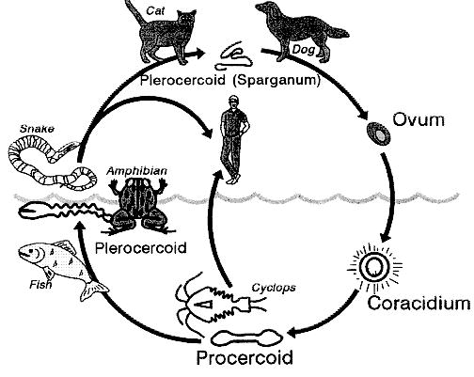
- Human may play role as 2nd . host especially those who eating raw meat of frogs or snakes in orients regions , or when drinking contaminated water by copepods.

